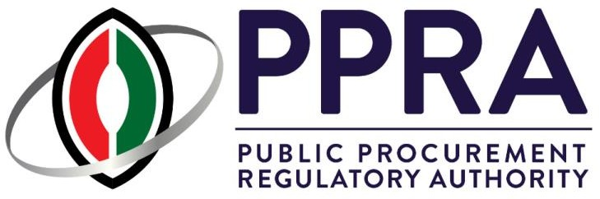

# Annex 4

CompanyAddress

P.O Box 58535 - 00200, Nairobi Kenya

Telephone: CompanyPhone

Email: CompanyEmail



## LicenceID

**Registration No: RegistrationNo**

## CERTIFICATE OF REGISTRATION AS PROCURING OR ASSET DISPOSAL AGENT

**Pursuant to Section 51(3) of the Public Procurement and Asset Disposal Act, 2015 and Regulation 38(1) of the Public Procurement and Asset Disposal Regulations, 2020 I hereby certify that**

_____Full_Name_____

**has been registered as a Procurement or Assets Disposal Agent ( CategoryName category of practice).**

**The Certificate is valid for 12 months from ExpDateFormat**

## ………………………………………….

**Director General**